Maharaja Surajmal Institute of Technology, New Delhi-110058
Department of Computer Science & Engineering
Activity Report
Event Agenda | Activity on Improving Soft Skills by the Placement Department
Speaker | Placement Cell
Date and Time | 29-09-2026
Venue | Lab 106A, First Floor, MSIT
Target Audience | 2nd Year B.Tech CSE Students
Organized by | CSE &Training & Placement Cell & CSE Dept. Maharaja Surajmal Institute of Technology
Total Participants | 50

Introduction
The CSE and Training & Placement Cell Department of Maharaja Surajmal Institute of Technology , Janakpuri, Delhi, organized an informative and interactive activity on “Improving Soft Skills” for the 2nd Year B.Tech CSE students. The activity focused on helping students understand the importance of effective communication and providing them with a practical opportunity to assess their existing English language skills.

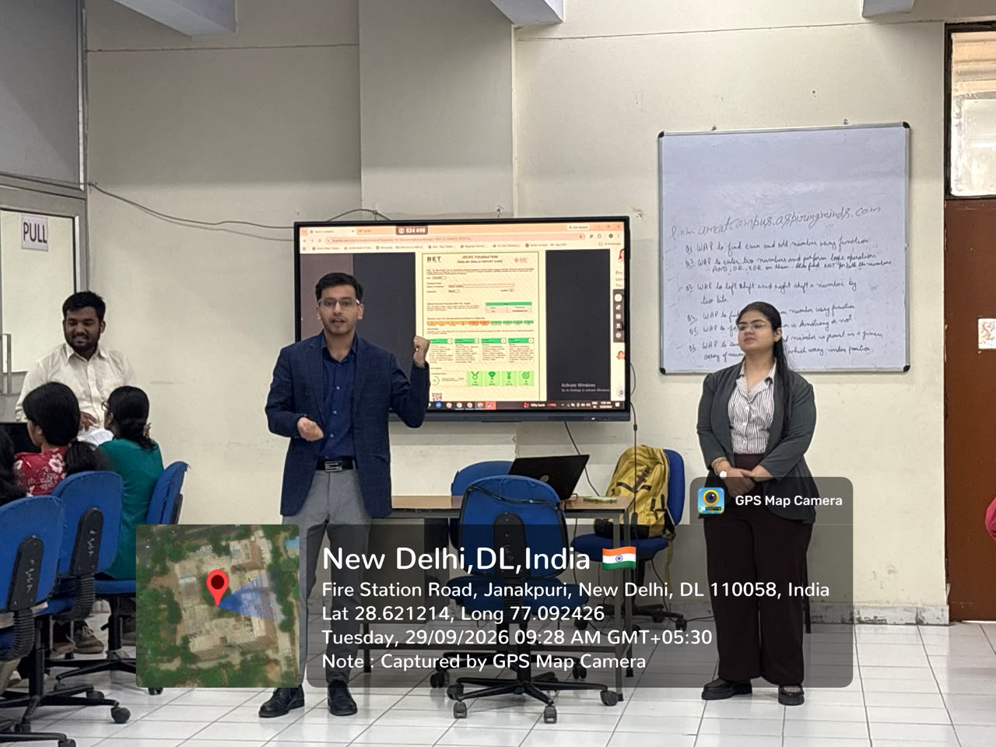
As part of the activity, students participated in a Baseline Assessment in the FluentEdge Bharat English Test (BET) 2026. The assessment provided students with hands-on experience in evaluating the four core language skills of Listening, Speaking, Reading and Writing .
Objective of the Activity
1. To help students understand the importance of soft skills in academic and professional life.
2. To provide students with an opportunity to assess their Listening, Speaking, Reading and Writing (LSRW) skills.
3. To provide hands-on experience through the FluentEdge Bharat English Test (BET) 2026.
4. To help students understand their individual performance through assessment scores.
5. To enable students to identify their strengths and areas requiring improvement.
6. To encourage students to continuously develop their communication skills for future academic and professional opportunities.
Key Areas Covered
1. Importance of soft skills and effective communication.
2. Listening skills.
3. Speaking skills.
4. Reading skills.
5. Writing skills.
6. Baseline assessment through the FluentEdge Bharat English Test (BET) 2026.
7. Individual performance assessment and scoring.
8. Identification of areas for improvement.
9. Importance of communication skills in future academic and professional opportunities.
Session Overview
The activity began with an introduction to the importance of soft skills and effective communication in a student's academic and professional journey. The Placement Cell explained how communication abilities play an important role in various academic and professional situations.
Students were then introduced to the FluentEdge Bharat English Test (BET) 2026, which was used as a baseline assessment of their English language skills. The assessment covered the four core areas of Listening, Speaking, Reading and Writing (LSRW).
Students were given 30 minutes to complete the assessment. During this period, they gained hands-on experience with the online platform and practically tested their communication skills.
After completing the assessment, students received their respective scores. These scores helped students understand their current level of performance and identify areas where they could focus on further improvement.
Website used for the assessment: https://www.corporate.bharatenglish.org
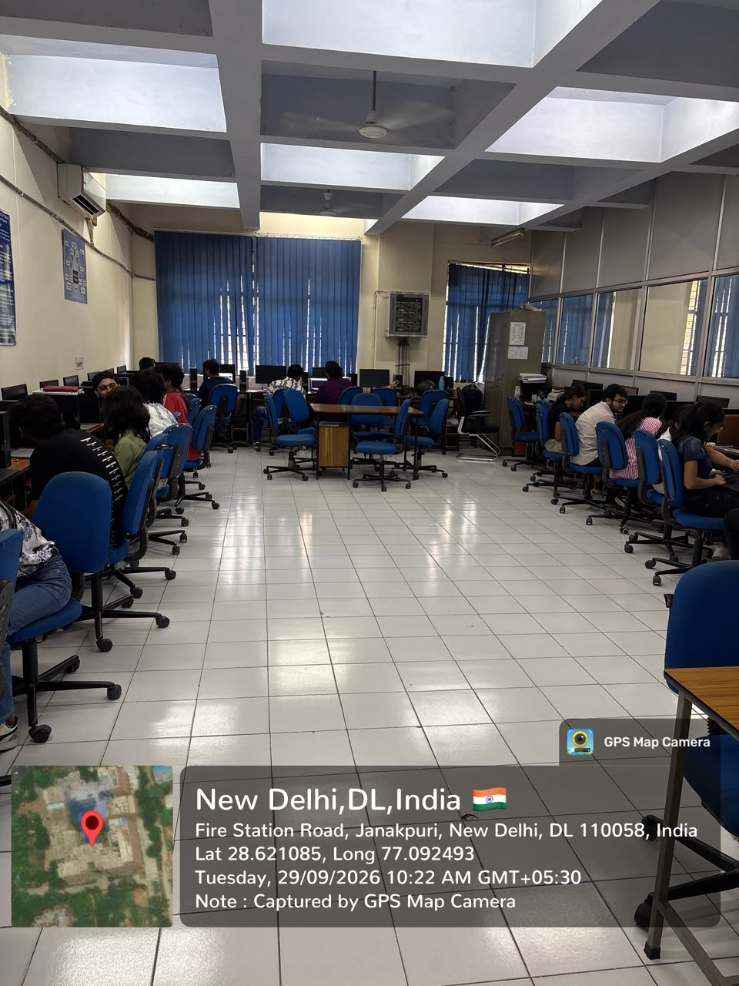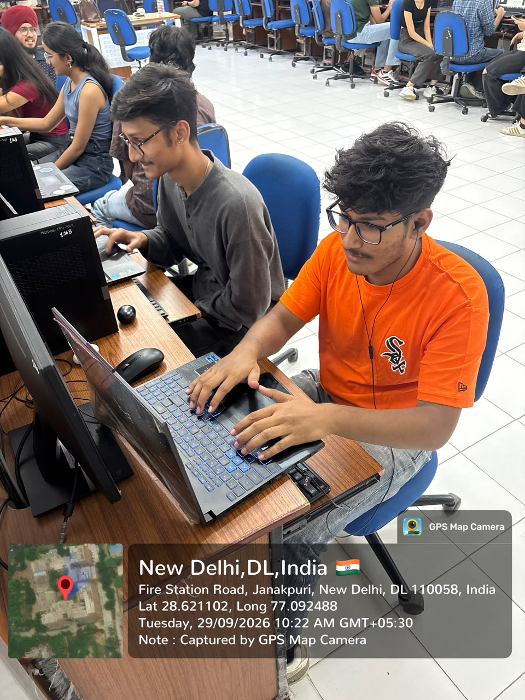

Student Interaction and Assessment
The activity witnessed active participation from more than 50 students. Students actively participated in the assessment and gained practical exposure to evaluating their Listening, Speaking, Reading and Writing skills.
The 30-minute assessment allowed students to assess their communication abilities in a structured manner. The individual scores obtained by the students provided them with a useful reference point to understand their strengths and areas requiring improvement.
The hands-on nature of the activity made the session meaningful and informative. It encouraged students to take greater awareness of their communication skills and provided them with a baseline that can be useful for tracking their improvement in the future.
Conclusion
The Activity on “Improving Soft Skills” conducted by the Training & Placement Cell proved to be an informative and meaningful experience for the 2nd Year B.Tech CSE students of MSIT. The FluentEdge Bharat English Test (BET) 2026 provided students with a practical opportunity to assess their Listening, Speaking, Reading and Writing skills.
The activity helped students understand their current performance and recognize the areas in which they can further develop their communication skills. Such practical assessments can help students become more aware of their abilities and prepare themselves for future academic and professional opportunities.
Acknowledgment
We extend our sincere gratitude to the Training & Placement Cell of Maharaja Surajmal Institute of Technology for organizing this informative and interactive activity. We appreciate the efforts of the Placement Cell in providing students with practical opportunities to assess and develop their soft skills and communication abilities.
Faculty Co-coordinators
Dr. Kavita Sheoran
Ms. Jyoti
Ms. Manju Dhull

HOD CSE (Morning Shift)
Dr. Naresh Kumar

